**Using InterVA App**

The InterVA SendingData app is to be used along with the provided ODK Collect Forms. Once you have everything set up in ODK Collect and have installed the InterVA apps, follow the steps below to ensure that everything works.

* After reaching the end of the ODK form you will see the following screen

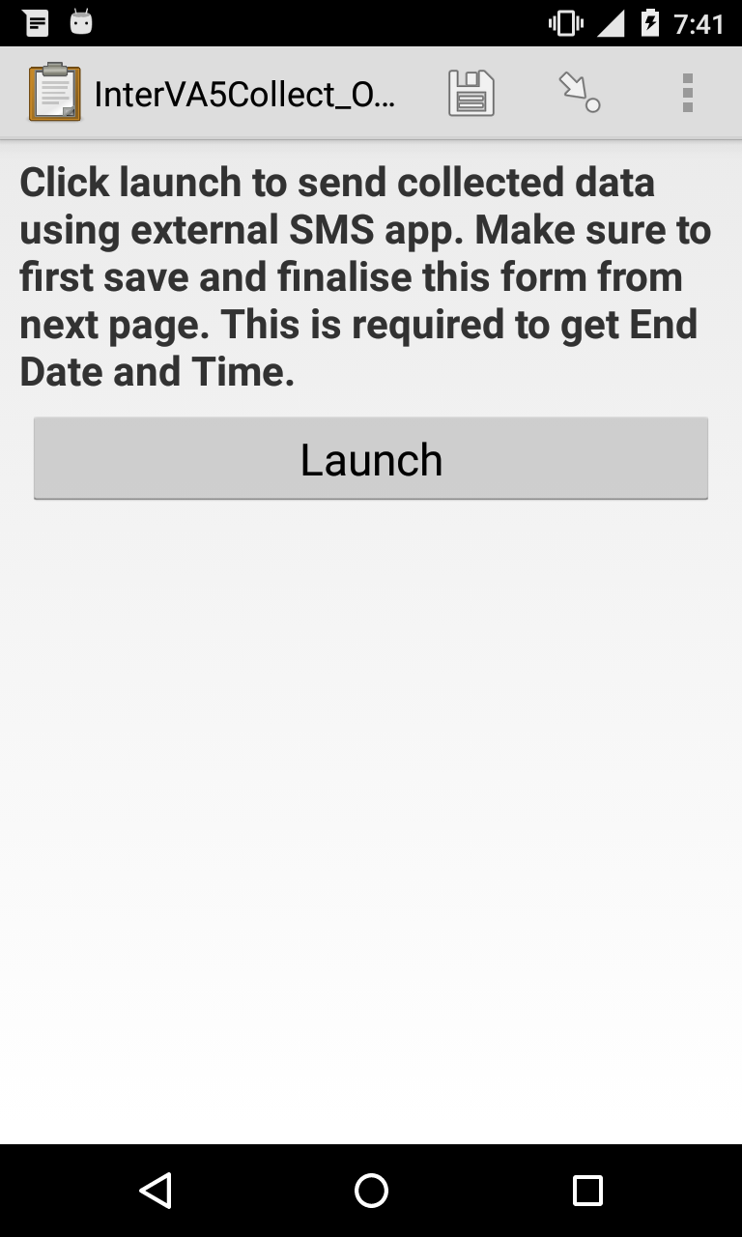

* DO NOT CLICK **Launch** YET
* Before sending the data to InterVA App, you need to **Save and Finalise** the form. This is to ensure that the End Data and Time is recorded and sent.
* Go to next screen, make sure that **Mark form as finalized** option is selected, give an appropriate name to the form and press **Save Form and Exit**

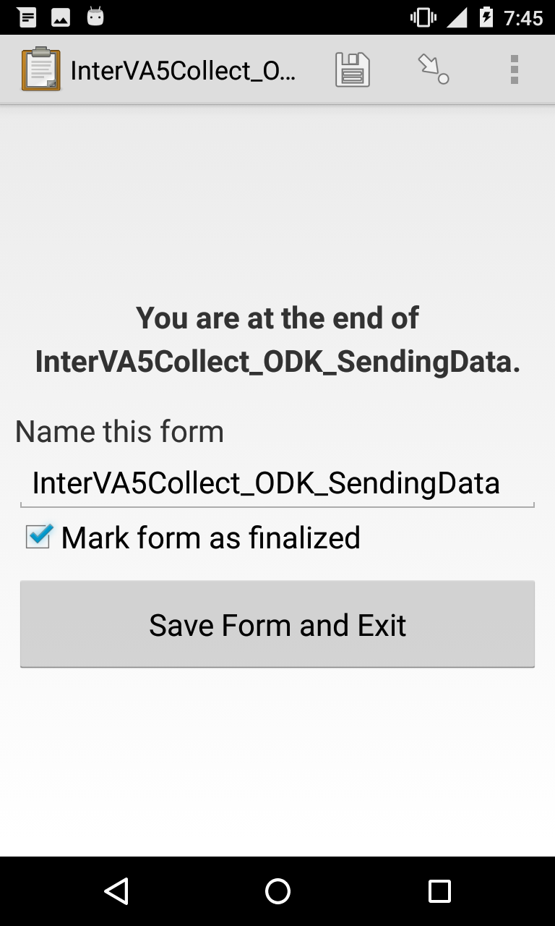

* Next, from the ODK Collect App, go to **Edit Saved Form** and open the form you saved

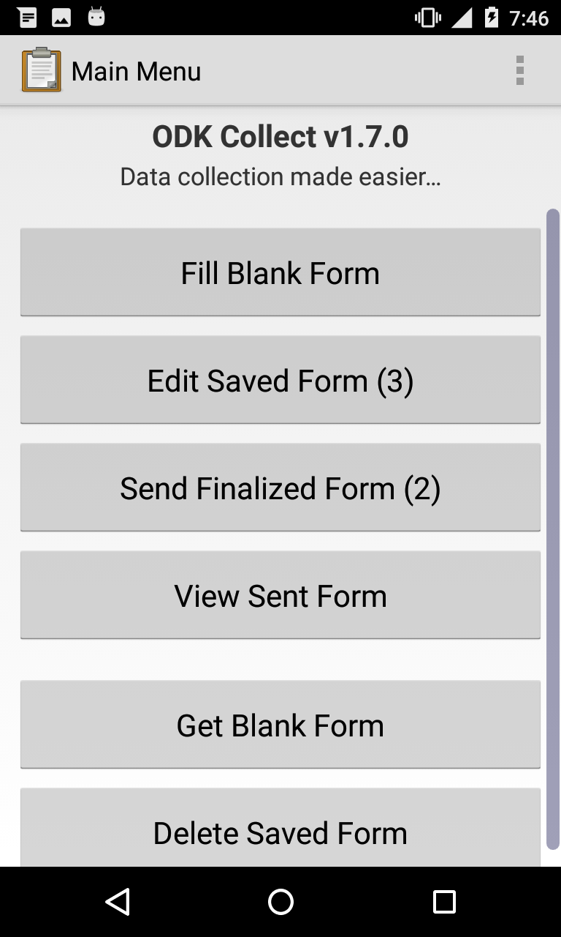

* **Go to End** of the form
* Swipe back to get the “**Click launch to send collected data….**” page in the form
* Click **Launch**
* InterVA SendingData app will open and ask for a phone number to send SMS to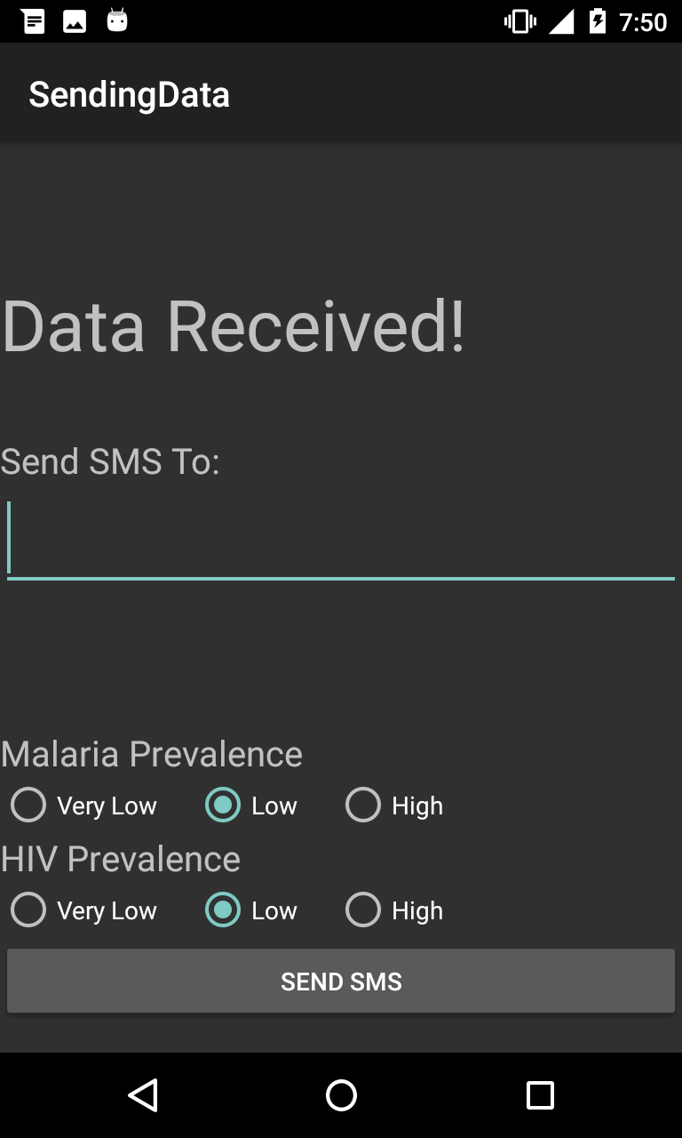
* Additionally you can also select the **Malaria** **Prevalence** and **HIV Prevalence** in your region
* Once everything is correct touch **Send SMS** button to send SMS
* You will be returned to ODK Collect App. Save the form and exit.

**Decoding InterVA SMS**

We have included a DecodeData app that looks at the received SMS and decodes it into readable data. To use this app follow the steps below.

* Open the **SMS Messaging App** on your phone. Select and Copy the SMS that you want to decode and close the app.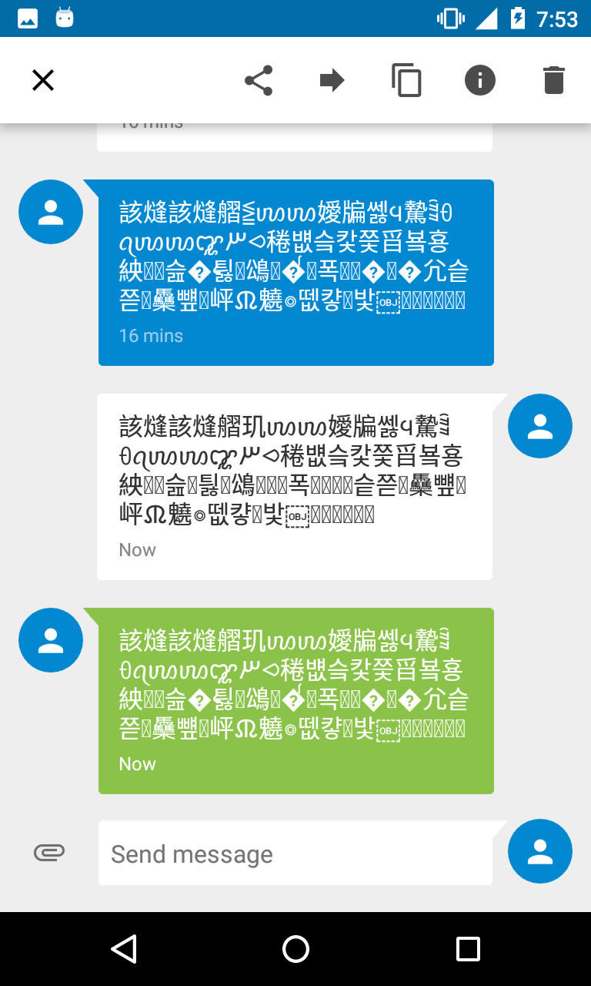
* Open **DecodeData** app and paste the SMS into provided space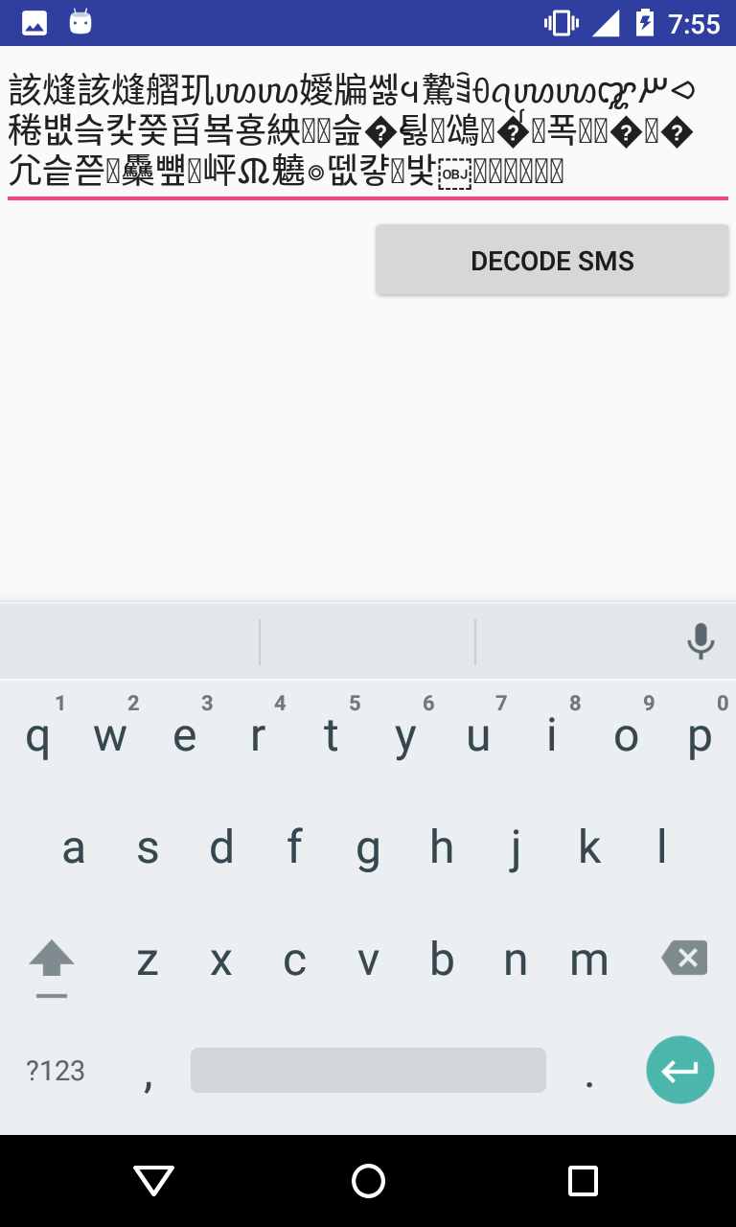
* Touch **Decode SMS** button to display the decoded data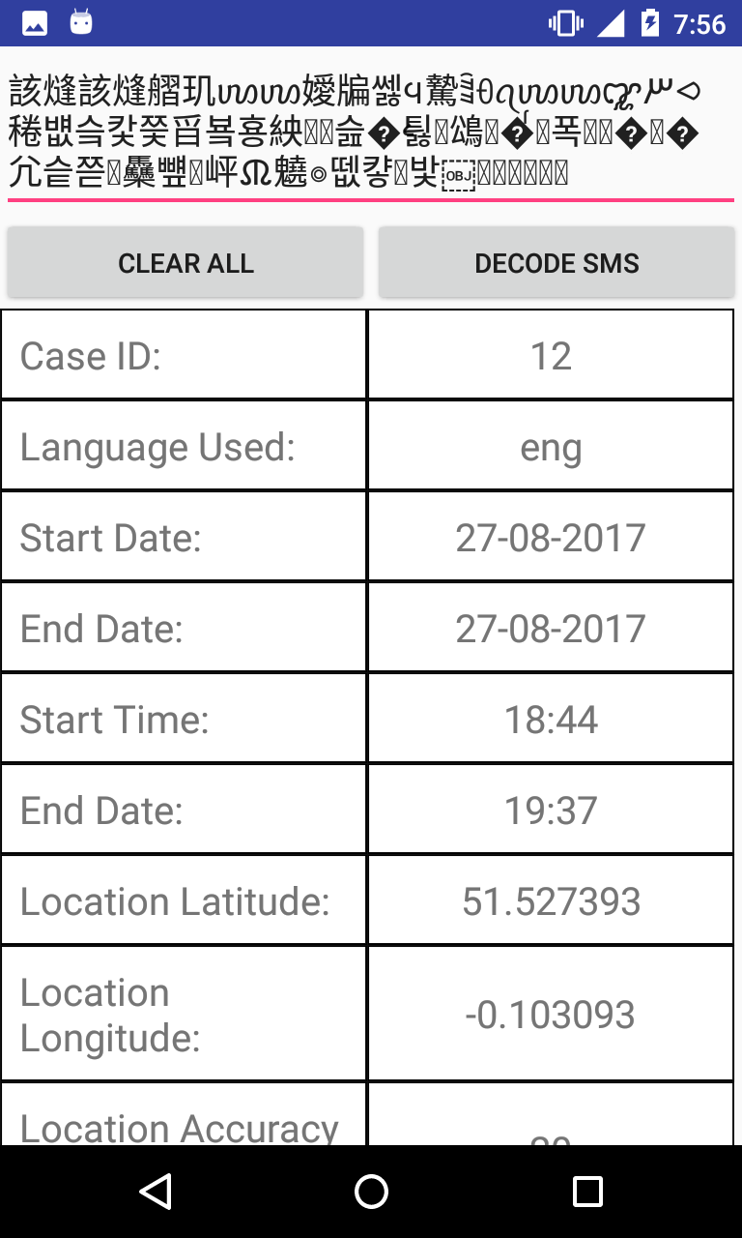
* You can scroll the table to see all entries
* If you want to decode more SMS messages then touch **Clear ALL** to clear the table